**Appendix 5**

**THE SPECIFIED PUBLIC PLACES, LONDON BOROUGH OF HARROW**

**PUBLIC SPACES PROTECTION ORDER 2023**

**This Order relates to Specified Public Places of the London Borough of Harrow, as listed and highlighted on the attached plan**

1**.** In this Order:

**‘Anti-Social Behaviour’** refers to section 59 (2) (a)-(b) of the Anti-Social Behaviour, Crime and Policing Act 2014 and means: activities carried out, or which are likely to be carried out, in a public space which have a detrimental effect on the quality of life those in the locality. This also means behaviour likely to cause harassment, distress or alarm to one or more other person. This can include, but is not limited to, littering, verbal abuse, obstructing the highway, illegal drug use, urinating or, spitting

‘**The designated area**’ refers to any public space to which the public or a part of the public has access (S 74(1) of the Anti-Social Behaviour, Crime and Policing Act 2014). This can be with payment, or with express or implied permission. This can include businesses and communal areas of housing blocks but excludes residential premises.

**‘Authorised officer**’ refers to: police officer, police community support officer, or any other person designated to enforce the Order by London Borough of Harrow. You can require any authorised officers to produce authorisation before enforcing the Order.

2. The London Borough of Harrow, in accordance with Section 59 (7)(a) of the Anti-Social Behaviour, Crime and Policing 2014, identifies the following activities in the designated areas, highlighted in section 3 to 12

of this Order, as having had a detrimental impact on the quality of life of those in the locality, or it is likely that they will have such an effect

3. **Bentley Priory Nature Reserve and The Viewpoint as shown highlighted on the attached plan in Appendices (‘the designated areas’)**

* Bentley Priory Nature Reserve - Dog control
* The Viewpoint indecent behaviour and causing damage

Due to the volume of reports of these activities and behaviours, the Council is satisfied that the effect, or likely effect, of the activities is, or is likely to be, of a persistent or continuing nature and these activities are unreasonable and justify the restrictions imposed by the notice and that it is in all the circumstances expedient to make this Order for the purpose of reducing anti-social behaviour in a public place.

The requirements and prohibitions set out below will relate to specific locations in the London Borough of Harrow and will be stated as such.

The London Borough of Harrow, being thereby satisfied that the conditions in Section 59 of the Act have been met, hereby makes the following Order:

4**. Bentley Priory Nature Reserve and The Viewpoint**

As shown outlined in red on the attached plans in Appendices (‘the designated areas’)

**Requirements - In the following specified public spaces within this designated area, you are required to:**

4.1 **Bentley Priory Nature Reserve - Dog control**

a. Keep dog(s) on a lead at all times within the designated area

**Prohibitions - In the following specified public places within designated area, you are prohibited from:**

4.2 **Bentley Priory Nature Reserve – Dogs not allowed in Boot Pond and Summer House Lake**

a. Allowing a dog(s) to enter or remain in Boot Pond or Summerhouse Lake

4.3 **Viewpoint and Viewpoint Car Park - Engaging in indecent behaviours and causing damage.**

a. Engaging in any indecent behaviours in the open or within a vehicle in the designated area

b. Causing damage by forcing vehicle entry/exit or driving over grassed areas in any part of the designated area without permission of the authority.

5. **Duration**

The Order comes into effect on [date 2023] and will be in effect for a period of three years, [Date 2026].

If there is need to do so, the Council may shorten, extend or vary the order at any time in the three years. If the Council wants to extend or vary the Order, they must consult appropriate community representatives, the police and owners of the affected land on the variation.

6. **Appeal**

If any ‘interested person’ (a person living in, working in, or regularly visiting the affected area) wishes to appeal this Order, they must do so on one of two grounds (s 66 of the Anti-Social Behaviour, Crime and Policing Act 2014):

1) The Council did not have the legal power to make the Order.

2) The Council did not follow all the requirements listed in Chapter 2 of the Anti-Social Behaviour, Crime and Policing Act 2014.

The interested person(s) must appeal the Order with an application to the High Court within six weeks of the Order being made.

7. **Information**

Further information about the PSPO and matters related within it, can be found at [www.harrow.gov.uk/licensing](http://www.harrow.gov.uk/licensing)

8. **Appendices**

1 Designated area - Bentley Priory Nature Reserve

2 Designated Area – The Viewpoint

**Appendix 1**

**Designated area – Bentley Priory Nature Reserve**

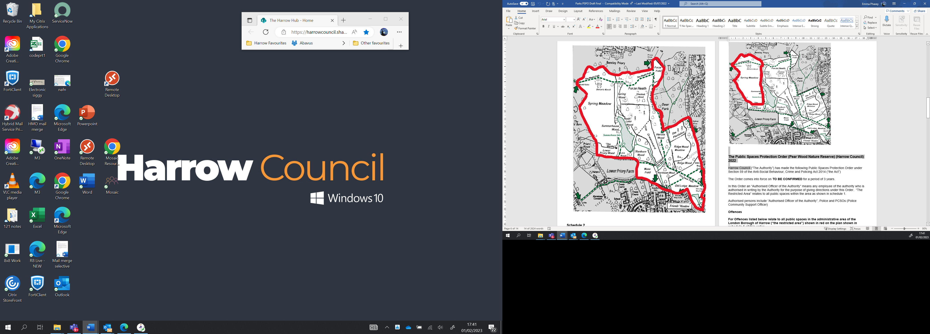

**Appendix 2**

**Designated area The Viewpoint**

